HEART FAILURE CLINICAL DATASET

I USED LOGISTIC REGRESSION SINCE IT IS A BINOMIAL DATA

FROM THIS DATASET I UNDERSTOOD THE DEATH RATE OF HEART FAILURE IS DUE TO ANY OF THOSE ATTRIBUTES GIVEN TO FIND WHICH IS THE MAJOR CAUSE FOR THIS DISEASE I USED LOGISTIC REGRESSION

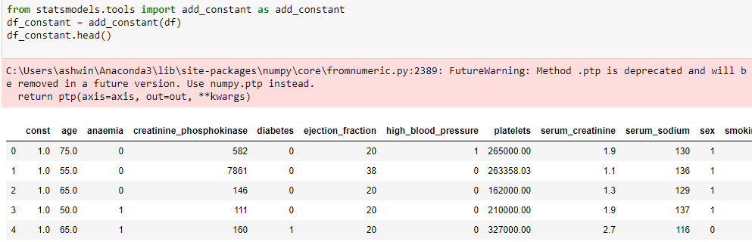

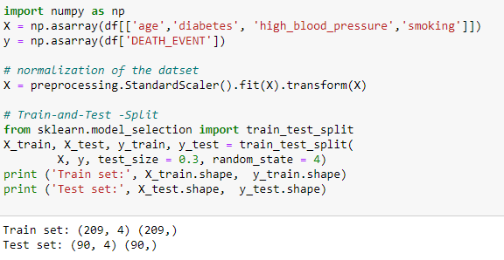

I USED TRAIN AND TEST DATA TO SPLIT AS DEPENDENT AND INDEPENDENT VARIABLE

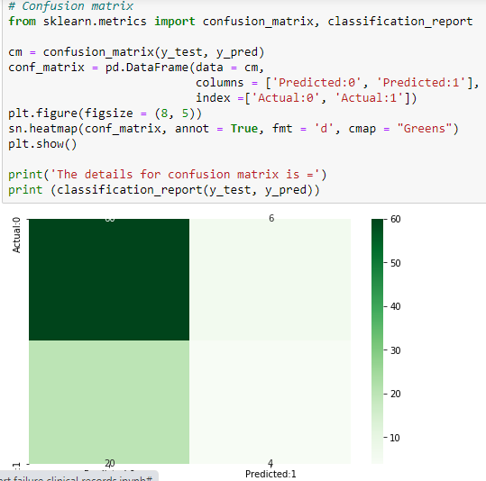

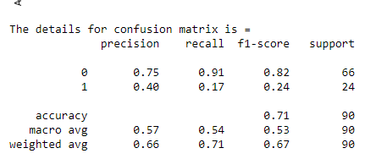

THEN USED CONFUSION MATRIX TO TEST THE ACCURACY

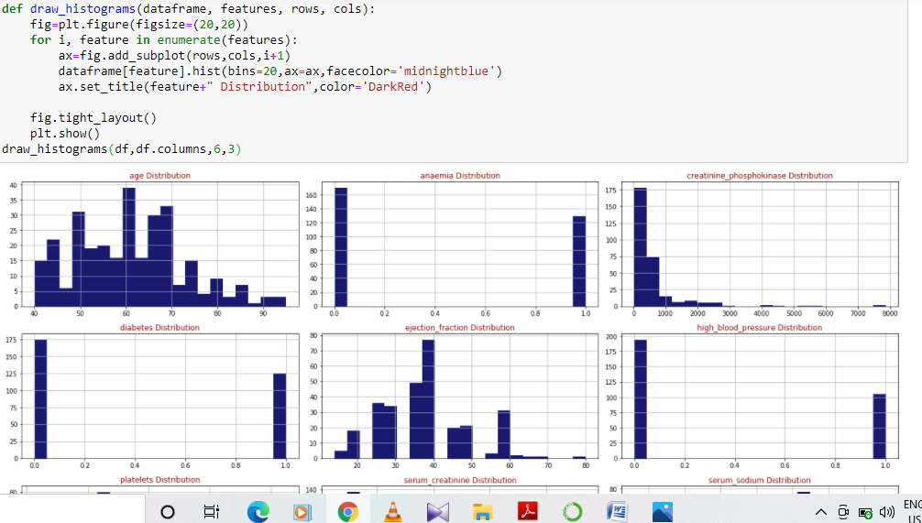

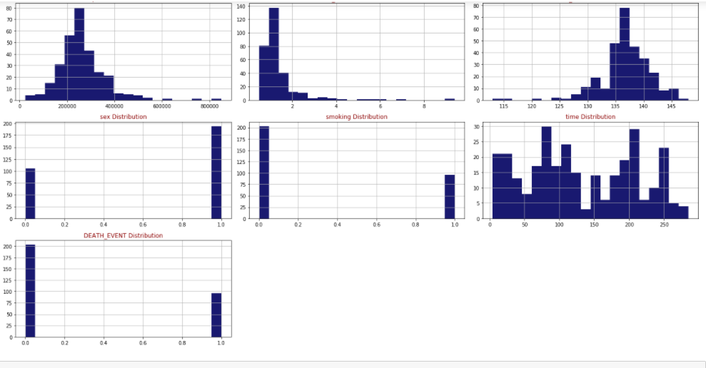

USED HISTOGRAM TO UNDERSTAND THE DISTRIBUTION OF ATTRIBUTES